

**E-Auction Application**

Submitted to

**Shaju Kuppelan**

Sr. Software Engineer B2

IDE FSE Java

shaju.kuppelan@cognizant.com



Created By

**Akash Kumar Gupta**

PAT| CDE Full Stack Engineer

AkashKumar.Gupta@cognizant.com



**Problem Statements**

The main purpose of E-Auction Application is to provide the ability to initiate sale, purchase and bid for a product by the customer. The core modules of E-Auction app are:

* Put a new product on auction with starting bid price.
* Bid of the product.
* Update the bid price.
* Enlisting of bids placed on any product.

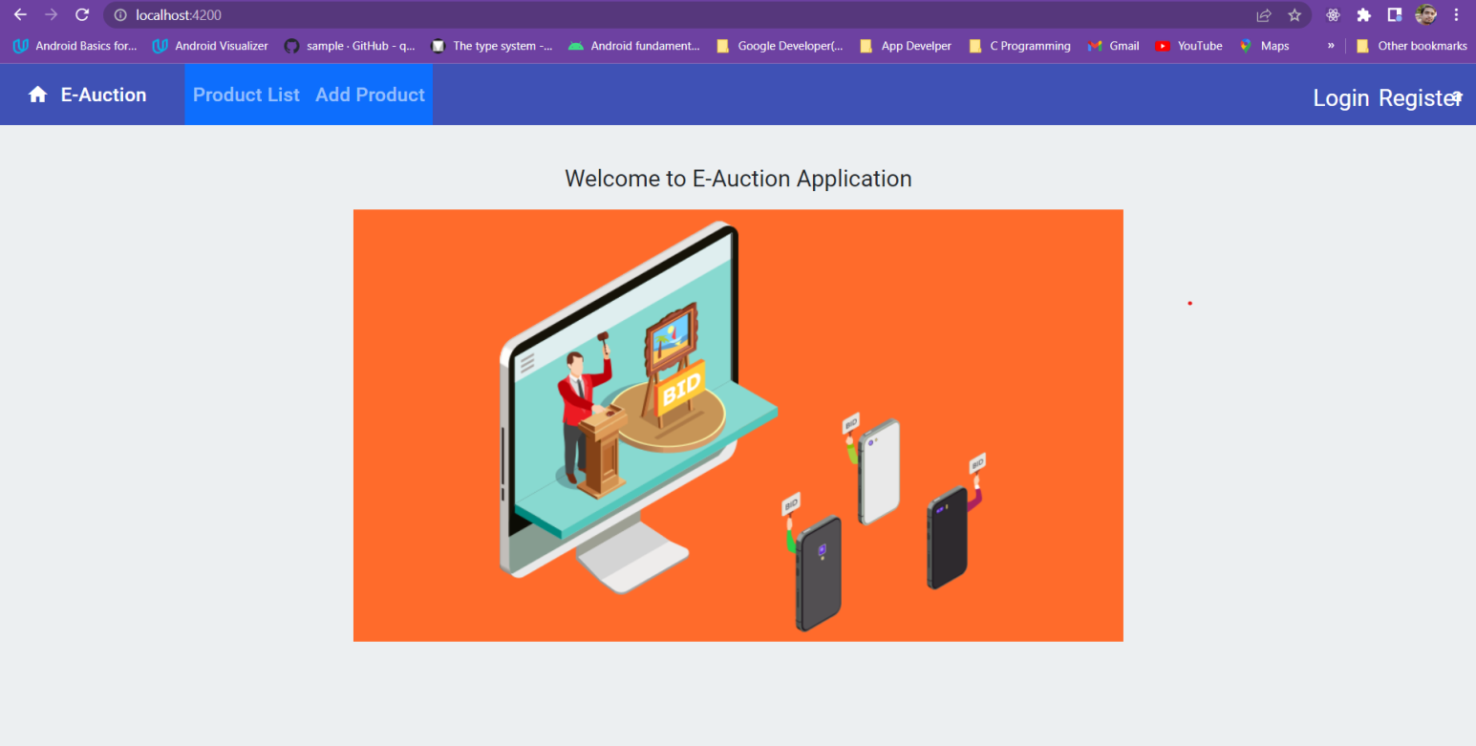

**Technology Used**

|  |  |
| --- | --- |
| **Back-end** | Java 8  SpringBoot  MySql |
| **Front-end** | Angular |
| **Tools** | STS  Postman  Visual Studio Code  MySql Workbench |

Use Case -1

Registration Page

A registration form is list of fields that a user will input data into and submit to a company or individual. There are many reasons why you would want a person to fill out a registration form. Companies use registration forms to sign up customers for subscriptions, services, or other programs or plans.

New users can register for the system using the registration page. A new user can sign up and register for the service by entering some details on the page.

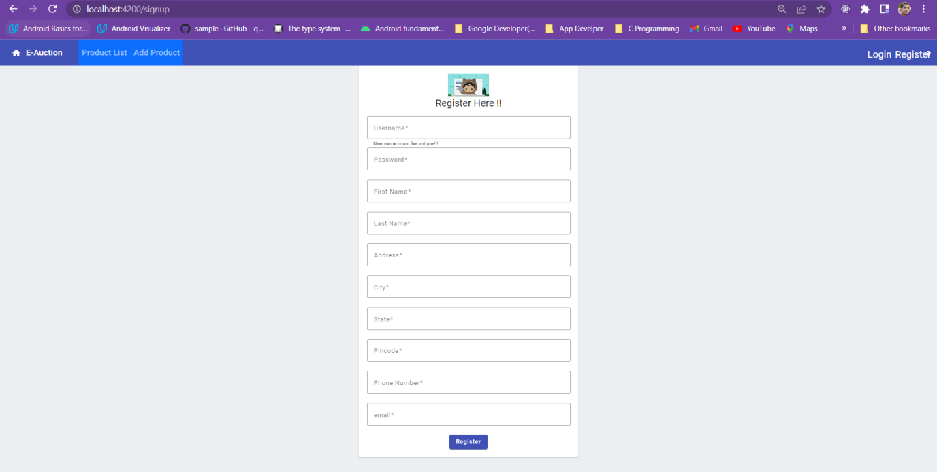

Use Case -2

Login Page

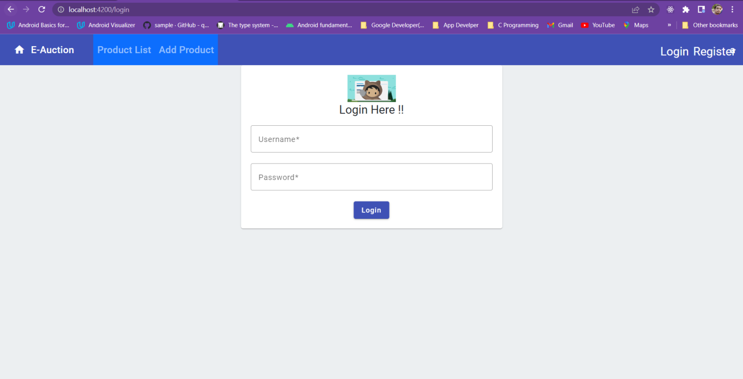Login page is the page where you can get authenticated before the access of the application. Web Application is the interface to the main server and you can access the application through web browser. Before accessing the secured part of the application you must authenticate yourself with the website by providing your username and password.

Use Case -3

Product List

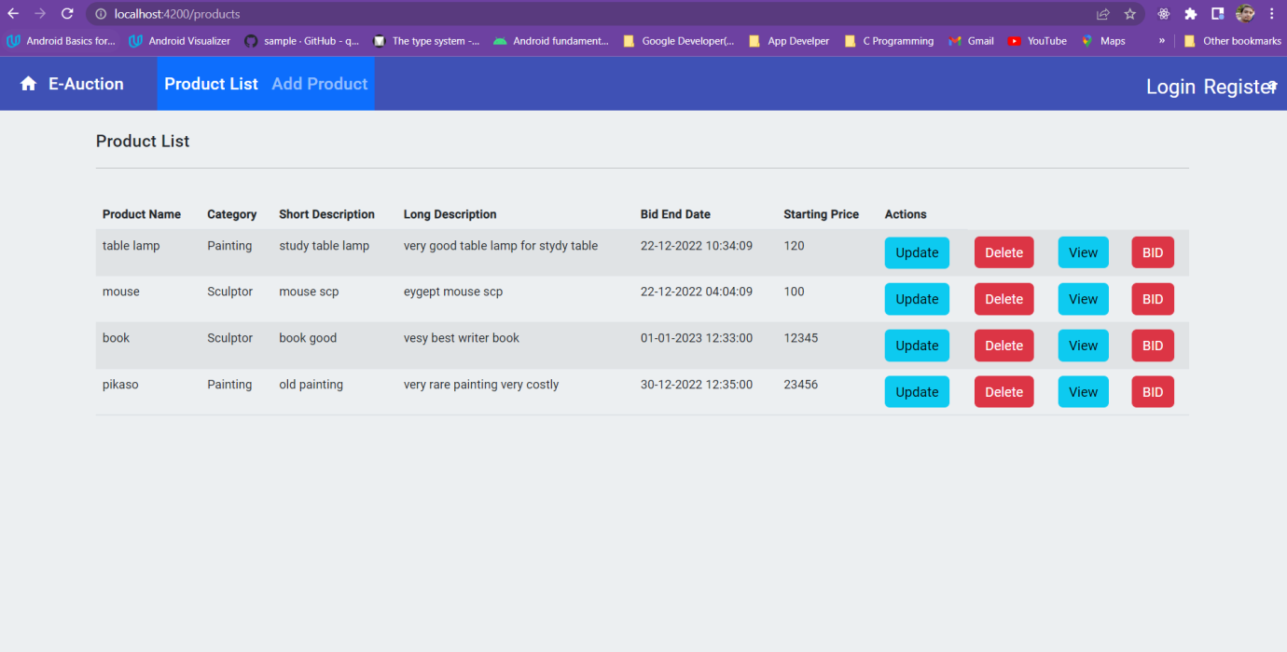As a customer, they can see the entire product available for bidding and also able to bid on that product. Also they can update the bid amount before the bid end for that product.

Use Case-4

Add Product

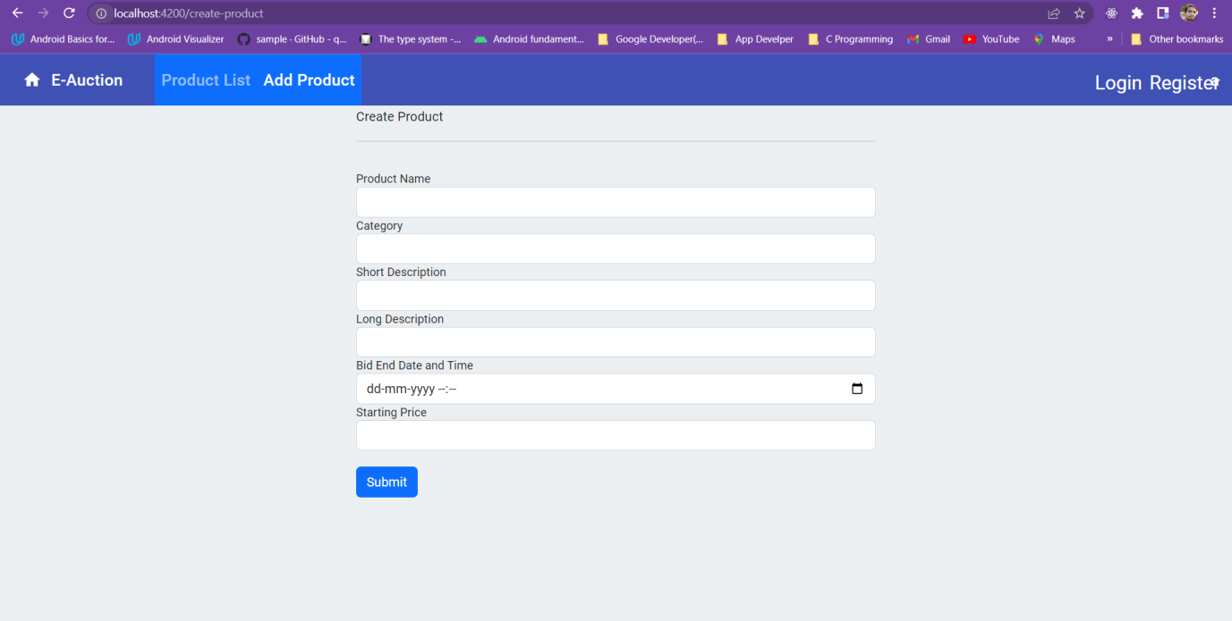As a seller one can add their product to the application to sell. Other user can able to bid on that product. Also they have all the rights to delete that product or withdraw the bidding.

